Dataset Description
● List of orders
Attributes: Order ID, Order Date, Customer Name, City, State, Category, Amount, Profit
*Change the data type using locale-(English Kingdom)
*Change data type Customer Name : Using Proper case
*Merge the City and State columns to create a new column named Location Separator to space

● Order Details
Attributes: Order ID, Category, Sub-Category, Quantity, Amount, Profit
*Change types amount columns to fixed decimal number
*Change types Profit columns to decimal number
*Change types Quantity columns to whole number
* Add column Custom column Enter =[Profit]/[Amount]
Create a custom column named Profit Margin calculated as: Profit / Amount
(expressed as a percentage)
● Sales Target
Attributes: Category, Month of Order Date, Target
*Change types Target columns to fixed decimal number
5. Conditional Column:
Add a conditional column named Profit Status
■ IF Profit Less than 0 → Loss
■ Eles IF Profit Equals 0 → Break-Even
■ Eles IF Profit great than 0 → Profit

6. Merging Data
* Merge Queries Selected List of Orders and Order Details tables choose Order ID.
*Table Expand Order date, Location, Customer name,
*Merged output table name as Orders Data.

7. Handling Missing Data & Duplicate Data
*Identify missing values across all tables.
*Removing errors record and remove null values from order date
8. Sorting and Filtering Data
* Sorting Orders Data table by Order Date in descending order.(Z-A)
*Apply filters to orders from a specific state Tamil Nadu
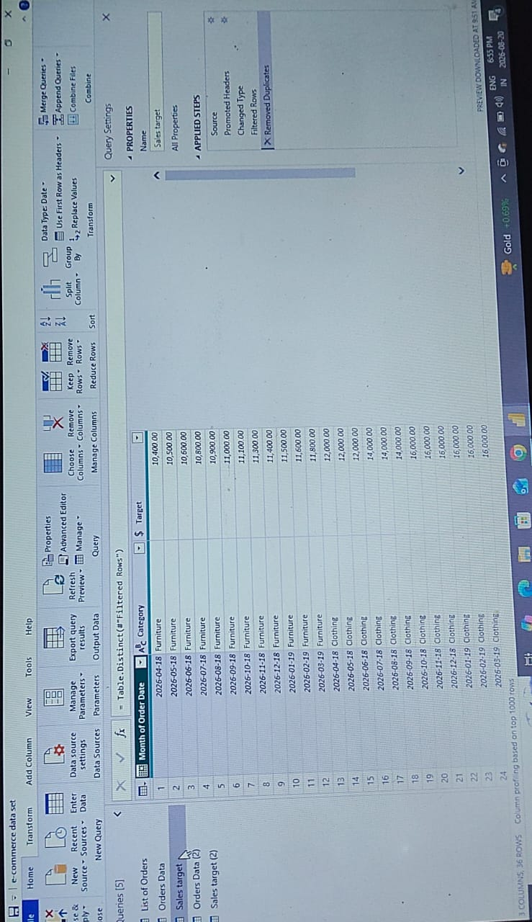

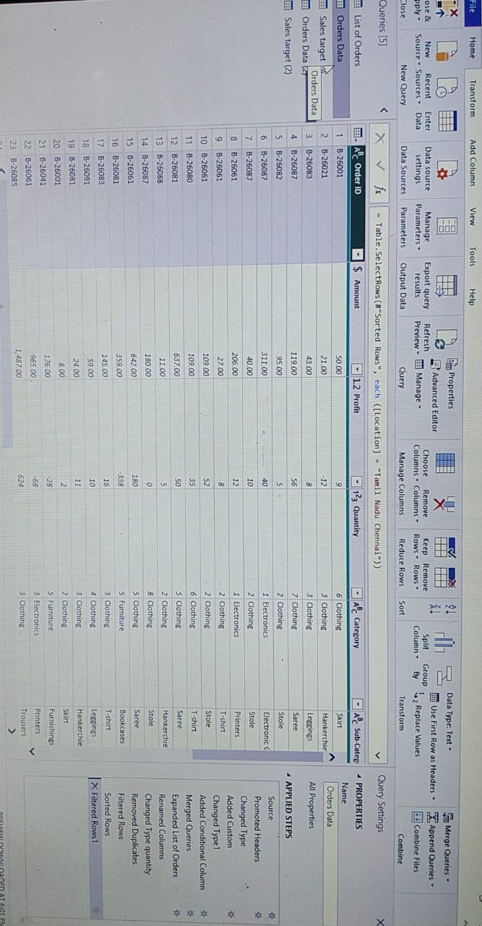

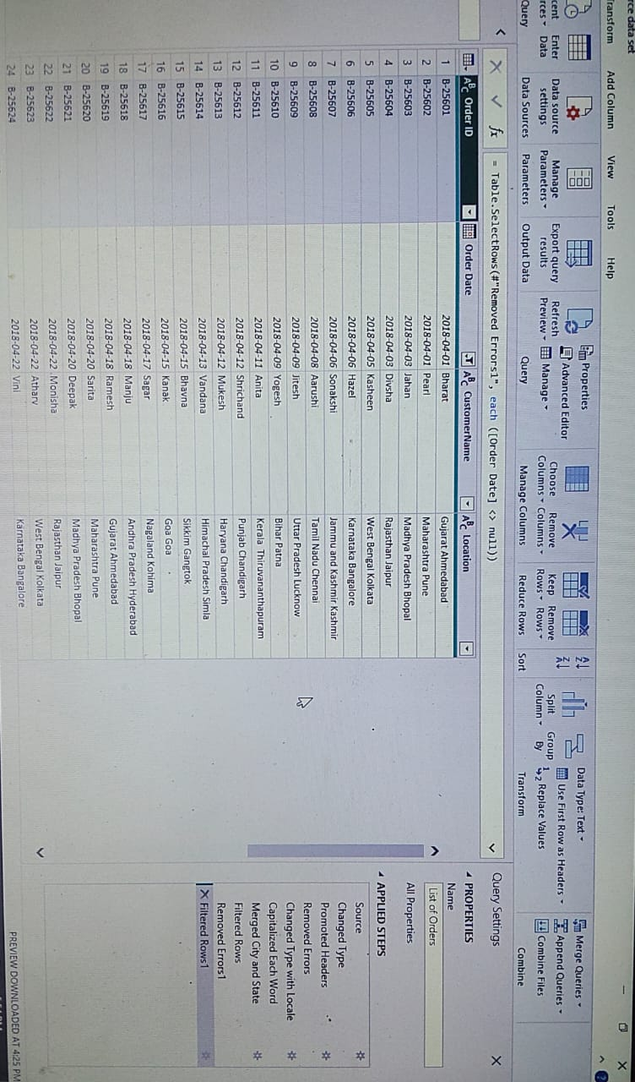

9. Grouping and Aggregating Data
*Duplicate the Order Details table and applied a group by on Category and Sub-Category
○ Count of Order ID
○ Average Profit by Category
○ Total Amount by Sub-category
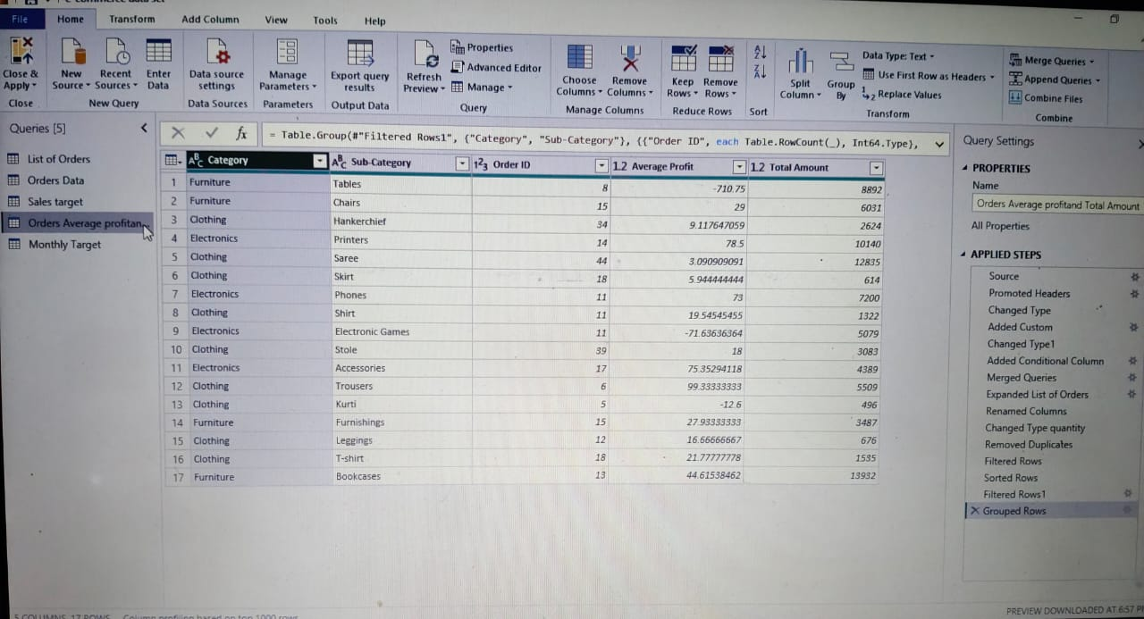
* Duplicate the Sales Target table and aggregate the total Target values grouped by Month of order date.
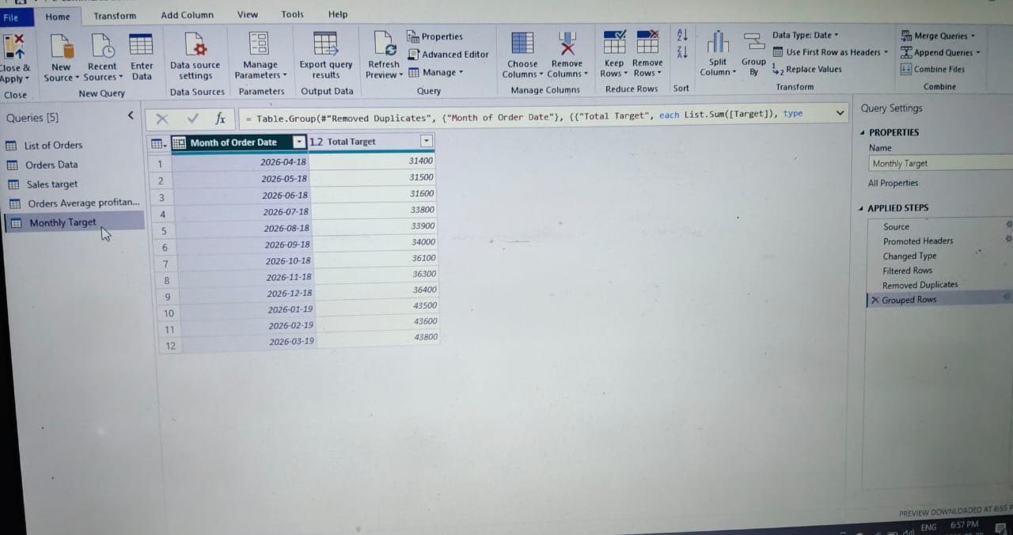

10. Data Modeling:
● Establish a relationship between:
○ List of Orders and Order Details using Order ID
● Establish a relationship between:
○ Order Details and Sales Target using Category
2. Use Manage Relationships to ensure relationships are active and correctly defined.
